**Add Sophistication to Your Dining Area with Elegant Mirrors**

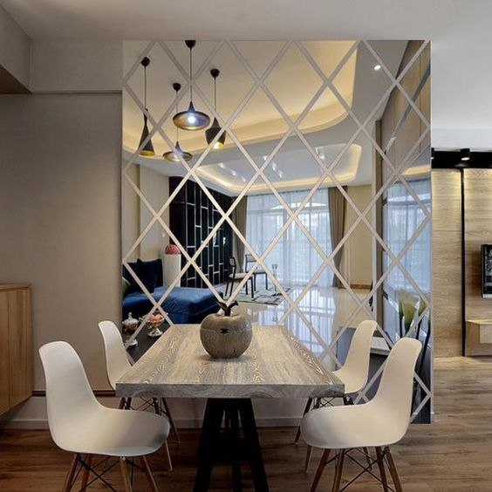The dining room is where family gathers, conversations flow, and memories are made — and the right mirror can amplify that warmth and elegance. Our handpicked collection of **Dining Room Mirrors** is designed to reflect not just light, but the atmosphere of togetherness and luxury. Strategically placed, these mirrors enhance the sense of space, improve lighting, and add a refined decorative touch to your dining setup.

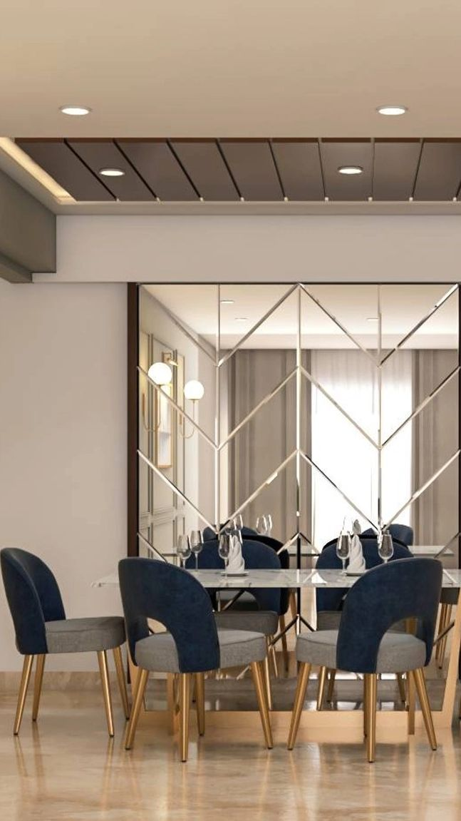Whether you prefer a large rectangular mirror above a sideboard, a round mirror that softens the room, or a geometric design for a contemporary feel — we offer a variety of styles to suit every dining room aesthetic. Framed in wood, metal, or antique finishes, these mirrors are crafted with care to seamlessly blend with your interior while becoming a visual highlight of the space.

Made from high-quality, distortion-free glass, our dining mirrors are both durable and beautiful. They help bounce natural or chandelier light across the room, creating an inviting and open atmosphere. Perfect for both everyday meals and formal gatherings, these mirrors enhance the charm and ambiance of your dining experience.

Reflect hospitality, warmth, and timeless design — all in one mirror.